**Information to support staff communications**

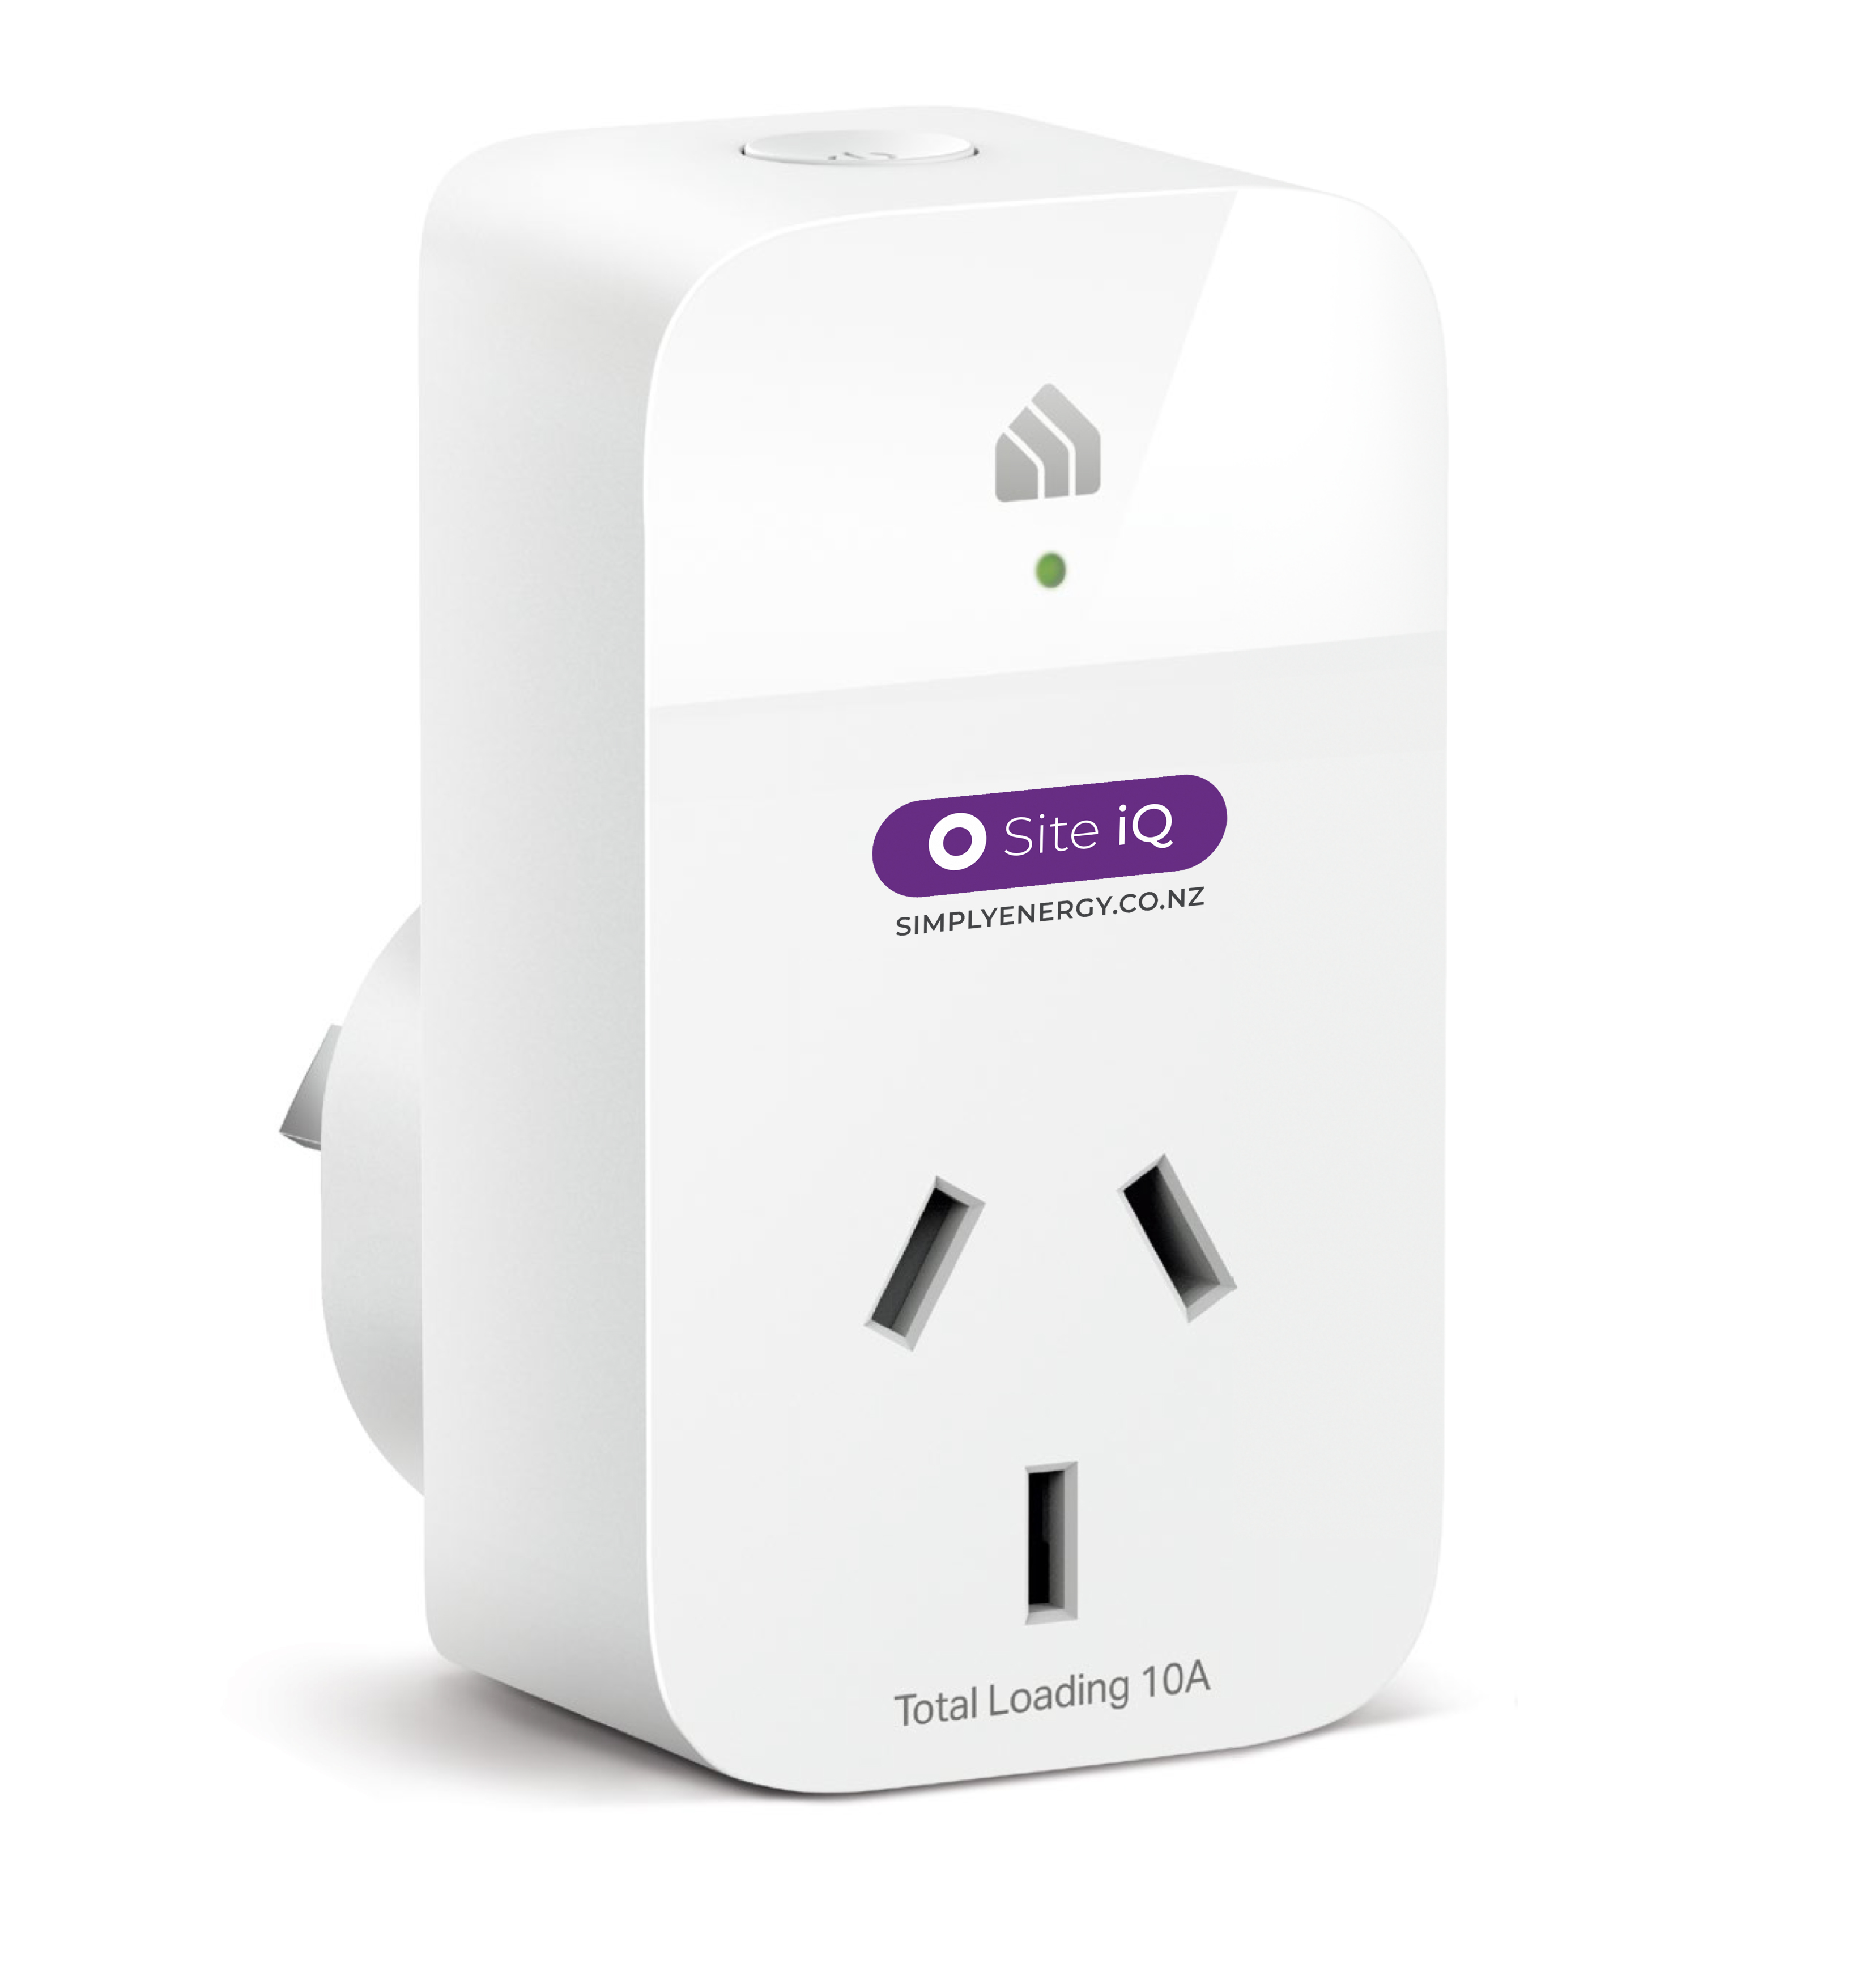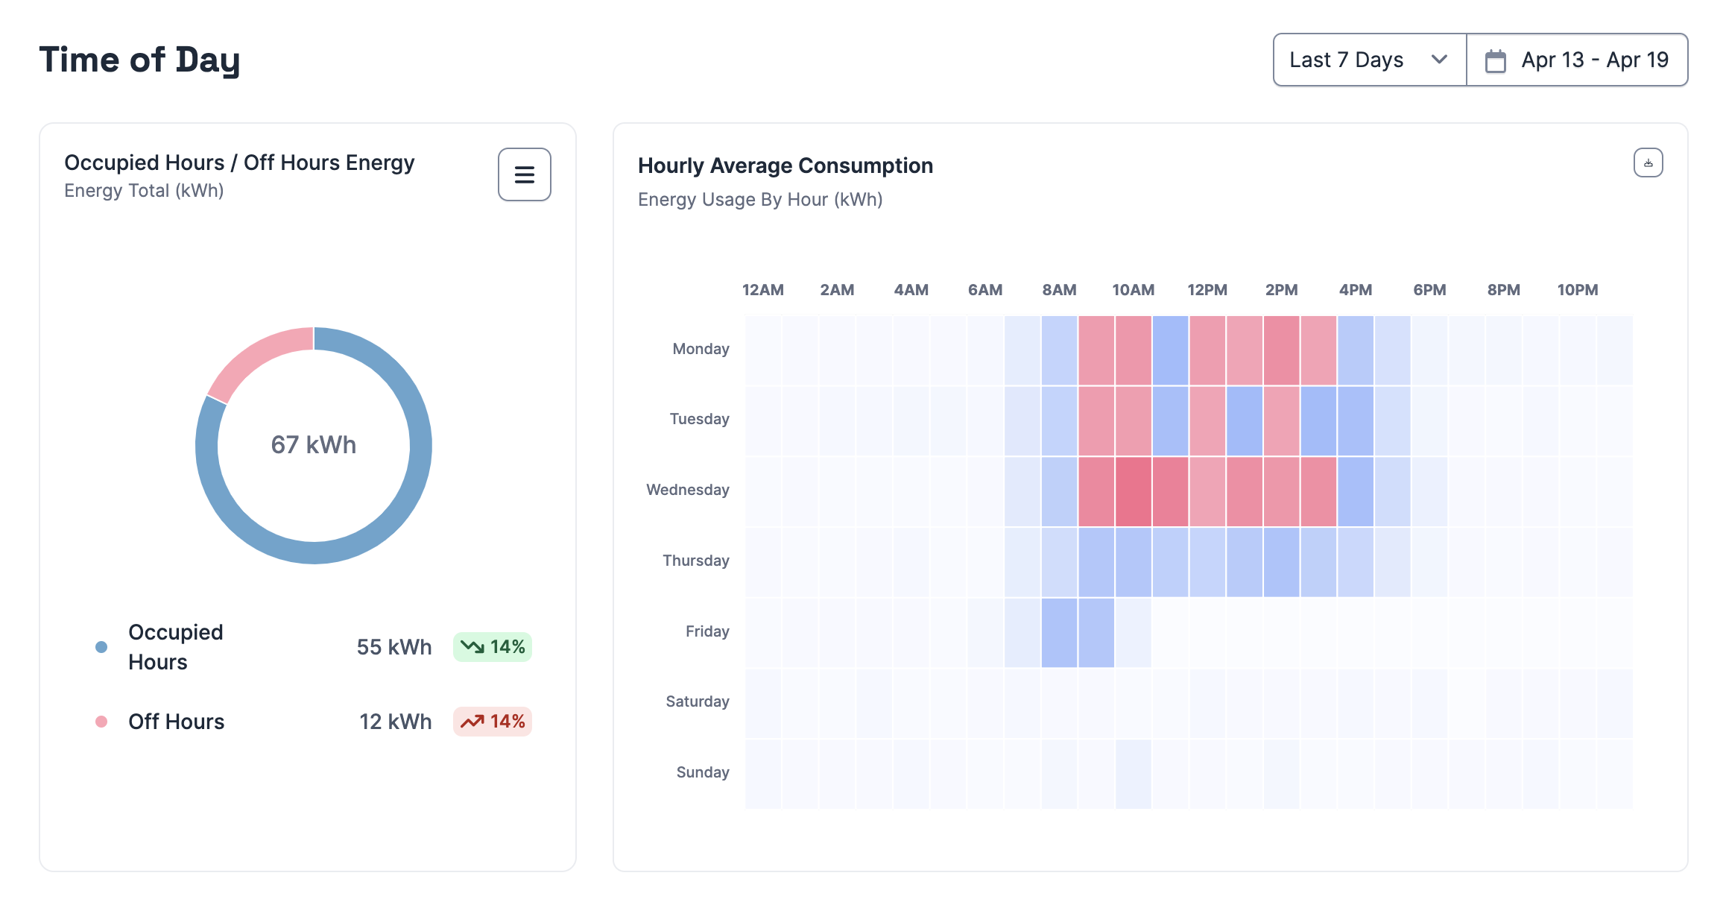

**How to use this information**

We’ve compiled some information to assist you in explaining Site iQ and its relevance to your staff. Feel free to adapt and use this resource in emails, on your intranet, or other communication channels.

We suggest communicating with your staff at four key moments:

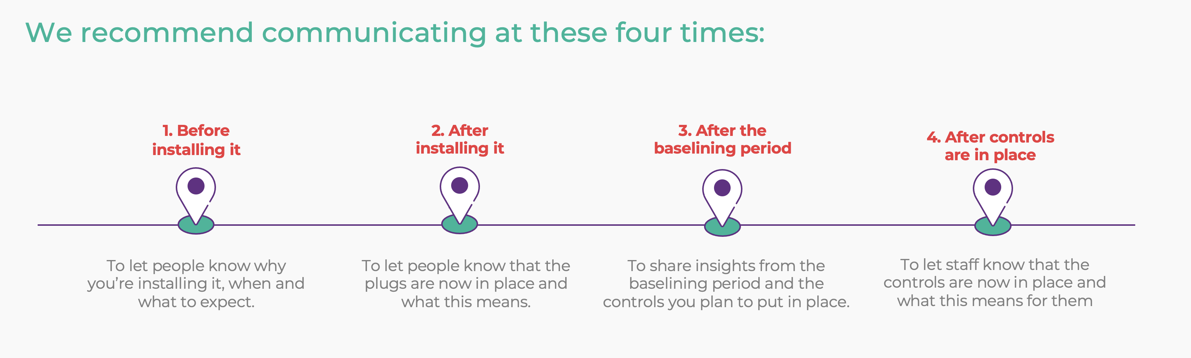

**Where to go for more information**

You’ll also find FAQs and other useful information in our [online toolkit](https://simplyenergy.co.nz/site-iq-online-toolkit/).

1. **Pre-installation communication**

**Purpose:** Use the information below to inform people about Site iQ. Explain why you’re installing it, what it does, and what to expect during the installation.

**Say hello to our new energy-saving initiative**

As you know, we’re always looking for ways to make our operations more sustainable. This month, we’re taking another important step by installing Site iQ, an energy and building analytics solution provided by Simply Energy.

Site iQ will help us reduce unnecessary energy consumption from devices such as computers, printers, TV monitors, and other appliances that use power when not in use. It will also help us optimise how we utilise our workspaces.

**What’s happening?**

On <date/time> Simply Energy will install smart plugs (like the one below) <insert locations>.

We’ll plug our equipment and appliances into them to collect data on energy consumption. This data, which is completely anonymous, will help us better understand our energy usage and make decisions to operate our equipment more efficiently. It will also give us insights into how we utilise our work areas.

When we initially install the plugs, we’ll keep them turned on to gather baseline data. After that, we’ll use the Site iQ platform to set controls that will automatically switch off equipment when it's not needed, like after hours, and turn it back on when it’s needed again.

**What this means for you**

You don’t need to do anything. Just keep in mind that these plugs must remain connected, so **please don’t unplug equipment from them, turn them off, unplug or move them**. If they happen to turn off, briefly press the top button to turn them back on. Pressing it for too long (more than 5 seconds) resets the plug, and we’ll need to reconfigure it. You can see if the plugs are online by looking at the status light on the front of the plug. If you need help, refer to this guide [include a link to our customisable guide which you can download [here](https://simplyenergy.co.nz/wp-content/uploads/2024/04/How-to-read-the-plug-status-light.pptx), once you’ve added the name of a contact person for Site iQ in your company and saved it somewhere accessible for everyone to use], which includes who to contact for questions or issues.

**If you’ve got questions or need help**

If you have any questions about Site iQ or need help, please get in touch with <contact name> or visit the [Site iQ online toolkit](https://simplyenergy.co.nz/site-iq-online-toolkit/), where you’ll find FAQs and other useful information.

**2. Site iQ post Installation communication**

**Purpose:** Use this information to let staff know that Site iQ has been installed and what this means for them.

**Site iQ is now up and running**

You will have noticed smart plugs (like the one below) installed around our office.

For the next <add duration of baselining period>, the plugs will collect baseline energy data so we can see how much energy our equipment and appliances are using, and how we’re making use of our work areas.

After that, we’ll use the Site iQ platform to set controls that will automatically switch off equipment when it's not needed, like after hours, and turn it back on when it’s needed again.

**What this means for you**

You don’t need to do anything. Just keep in mind that these plugs must remain connected, so **please don’t unplug equipment from them, turn them off, unplug or move them**. If they happen to turn off, briefly press the top button to turn them back on. Pressing it for too long (more than 5 seconds) resets the plug, and we’ll need to reconfigure it. You can see if the plugs are online by looking at the status light on the front of the plug. If you need help, refer to this guide [include a link to our customisable guide which you can download [here](https://simplyenergy.co.nz/wp-content/uploads/2024/04/How-to-read-the-plug-status-light.pptx), once you’ve added the name of a contact person for Site iQ in your company and saved it somewhere accessible for everyone to use], which includes who to contact for questions or issues.

**If you’ve got questions or need help**

If you have any questions about Site iQ or need help, please get in touch with <contact name> or visit the [Site iQ online toolkit](https://simplyenergy.co.nz/site-iq-online-toolkit/), where you’ll find FAQs and other useful information.

**3. Site iQ baselining insights and control-setting communication**

**Purpose:** Use his information to share insights from the baselining period and to let staff know what equipment controls you’ve put in place. This is especially important if you decide you want people to turn their workstation plug on when they arrive in the office or if they’re working when the plugs are scheduled to be off.

**We’re now plugged into energy savings.**

After <insert duration of baselining period> of collecting data on how our equipment and appliances use energy with Site iQ, we’ve gained some great insights into how we can run them more efficiently.

[include key insights]

**What happens now?**

Based on these insights from <date>, we’ll be setting controls to operate our equipment more efficiently.

*These include:*

[Add information about the automated controls you’ve decided to set for equipment. For example, automatically turning workstations off at <x pm>].

**What this means for you**

[Let staff know about how the automated controls you plan to set will affect them. For example, “IfBottom of Form. you’re working when the plugs are scheduled to be off, briefly press the button on the top of the plug to turn your workstation back on. Pressing it for too long (more than 5 seconds) resets the plug, and we’ll need to reconfigure it. Please also keep in mind that these plugs must remain connected, so **please don’t unplug equipment from them, unplug or move them**.”]

If you need help, refer to this guide [include a link to our customisable guide which you can download [here](https://simplyenergy.co.nz/wp-content/uploads/2024/04/How-to-read-the-plug-status-light.pptx), once you’ve added the name of a contact person for Site iQ in your company and saved it somewhere accessible for everyone to use], which includes who to contact for questions or issues.

[Add any specific instructions for what you want staff to do when they leave. For example. “ Option 1: Turn off the plug when you leave. Option 2: Leave the plug on. The controls will reset in the next daily cycle.]

**If you have any questions or need help**

If you have any questions about Site iQ or need help, please get in touch with <contact name> or visit the [Site iQ online toolkit](https://simplyenergy.co.nz/site-iq-online-toolkit/), where you’ll find FAQs and other useful information.

**4. Controls are now in place communication**

**Purpose:** Use his information to let staff know that the controls are now in place and how this impacts them.

**Our Site iQ smart plug controls are now in place**

We just wanted to let you know that the controls we’ll use to operate our equipment and appliances more efficiently are now in place.

[reiterate controls from previous communication]

**What this means for you**

[reiterate impact of controls from previous communication]

Please also keep in mind that these plugs must remain connected, so **please don’t unplug equipment from them, unplug or move them**.

If you need help, refer to this guide [include a link to our customisable guide which you can download [here](https://simplyenergy.co.nz/wp-content/uploads/2024/04/How-to-read-the-plug-status-light.pptx), once you’ve added the name of a contact person for Site iQ in your company and saved it somewhere accessible for everyone to use], which includes who to contact for questions or issues.

**If you have any questions or need help**

If you have any questions about Site iQ or need help, please get in touch with <contact name> or visit the [Site iQ online toolkit](https://simplyenergy.co.nz/site-iq-online-toolkit/), where you’ll find FAQs and other useful information.